**IELTS** GENERAL WRITING TASK 1

**TIPS** 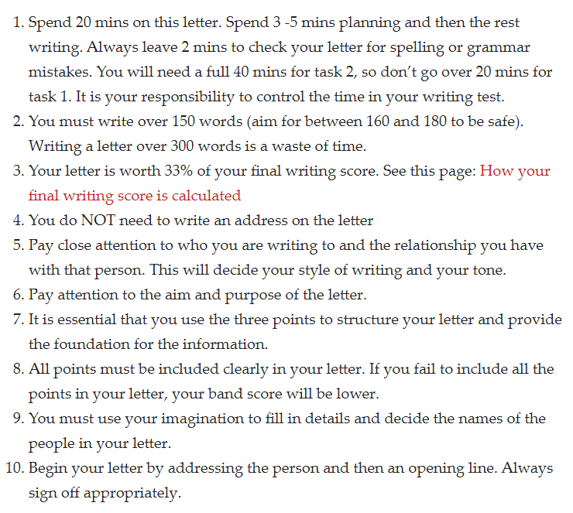

**TYPES OF LETTER**

* **Informal**

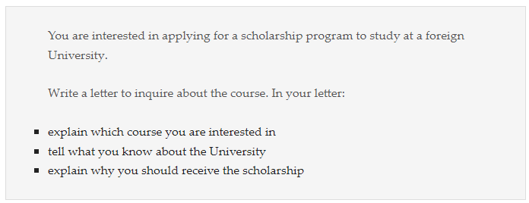

* **Formal**

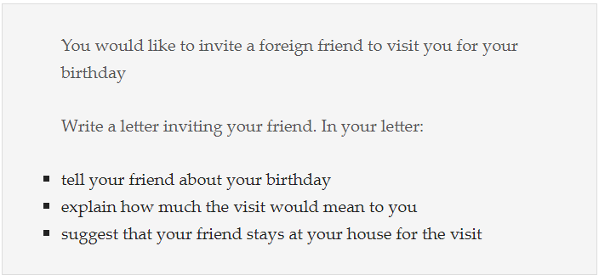

* **Semi-formal**

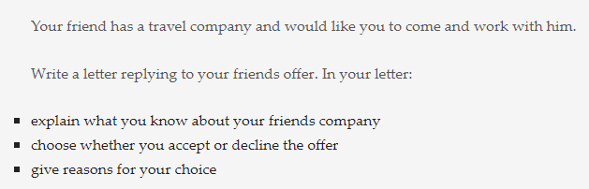

**LETTER AIMS**

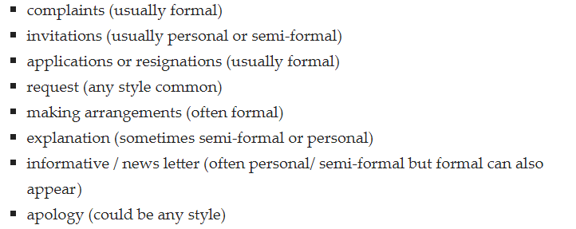

Congratulation

Thank you

Condolescene

**PLAN YOUR LETTER**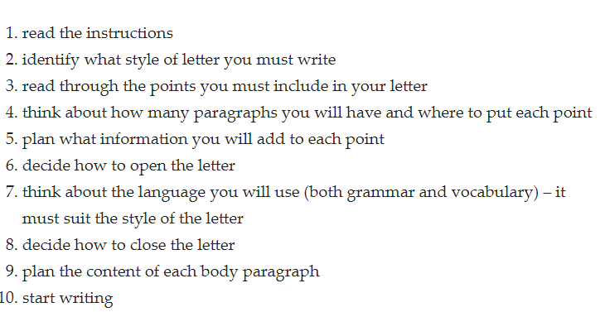

**WRITING CRITERIA**

1. Task Achievement
2. Lexical Resources
3. Grammar Accuracy
4. Coherence & Cohesion

**LETTER DETAIL**

1. General information
2. Instruction
3. Details

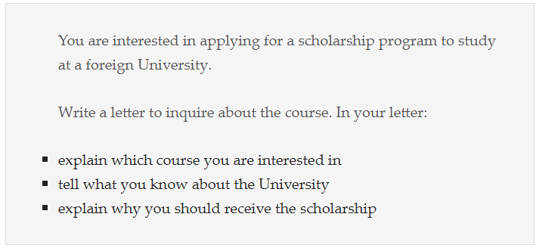

**LETTER STRUCTURE**

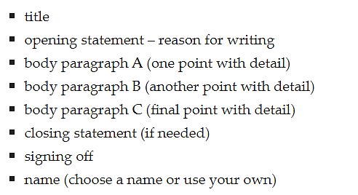

**COMPLAIN LETTER**

1. 1. Dear Sir/Madam, (or name if given)
2. 2. Explanation: 1-2 sentences what you are complaining about
3. I am writing to express my dissatisfaction with the ... / my concern about
4. I am writing to complain about ... / I had been led to believe ...
5. Please let me elaborate on exactly my situation.

**3. Explain in more detail (at the time you bought – condition 🡪 used for how long – condition 🡪 details of condition 🡪 feeling)**

* + **what are you unhappy about**
  + You can imagine how unhappy I was to discover ...
  + I regret to inform you that your service was below my expectations.
  + **what did you do to resolve the situation**
  + I contacted your store immediately in order to ...
  + When I tried to contact you by phone no one could offer me any sensible answer.
  + **how do you feel about the problem**
  + You can imagine how receiving this offer upset me.

**4. What action do you want the person or company to take / What would you like them to do, what will you do?**

* + The ideal solution would be ... / Nevertheless, I hope/assume you will replace ...
  + I hope you can settle this matter by ... (doing sth)
  + I insist on getting a refund of ...
  + I am very disappointed with the ... . Therefore, I expect a full refund of $100 as soon as possible.
  + **I hope this matter will be resolved / I trust the situation will improve.**

**5. Formal ending, name, signature**

* + I look forward to hearing from you!
  + I look forward to receiving a prompt reply!
  + Yours sincerely, ... (you know the name of the person you are writing to)
  + Yours faithfully, ... (you don't know the name!)

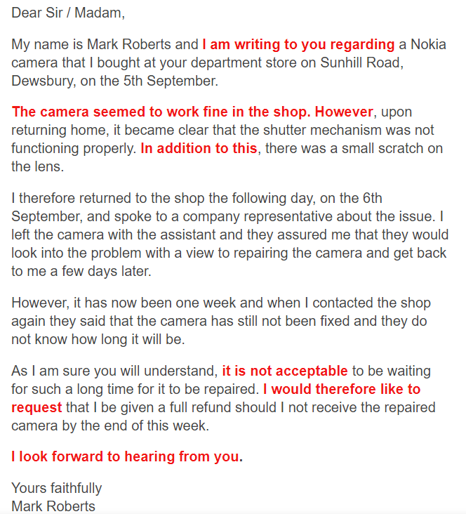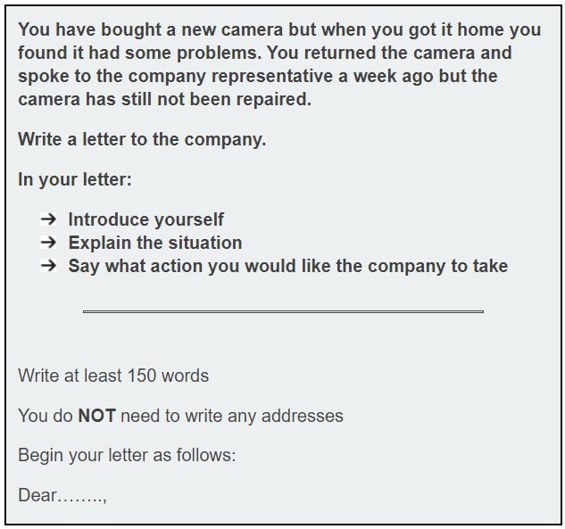

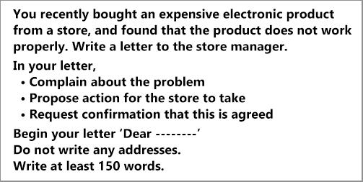



Dear Sir,

I am writing to express my dissatisfaction with món đồ. Please let me elaborate on exactly my situation.

Chi tiết. I contacted your store immediately in order to … but … You cannot imagine how receiving this offer upset me.

As a solution, I suggest that Giải quyết 1. Giải quyết 2. If not, I expect a full refund of $100 as soon as possible.

I await your response and hope this matter can be solved very soon.

Yours faithfully,

Van.

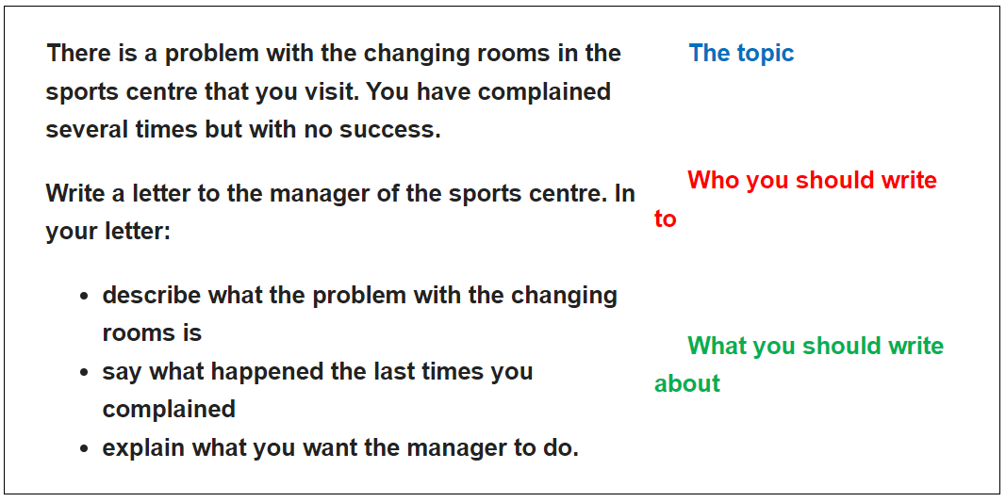

1) **Dear .....**  
2) **Paragraph 1:** Purpose – why you are writing

3) **Paragraph 2:** Write about 1st bullet point

4) **Paragraph 3:** Write about 2nd bullet point

5) **Paragraph 4:** Write about 3rd bullet point

6) **Closing**

7) **Signoff**

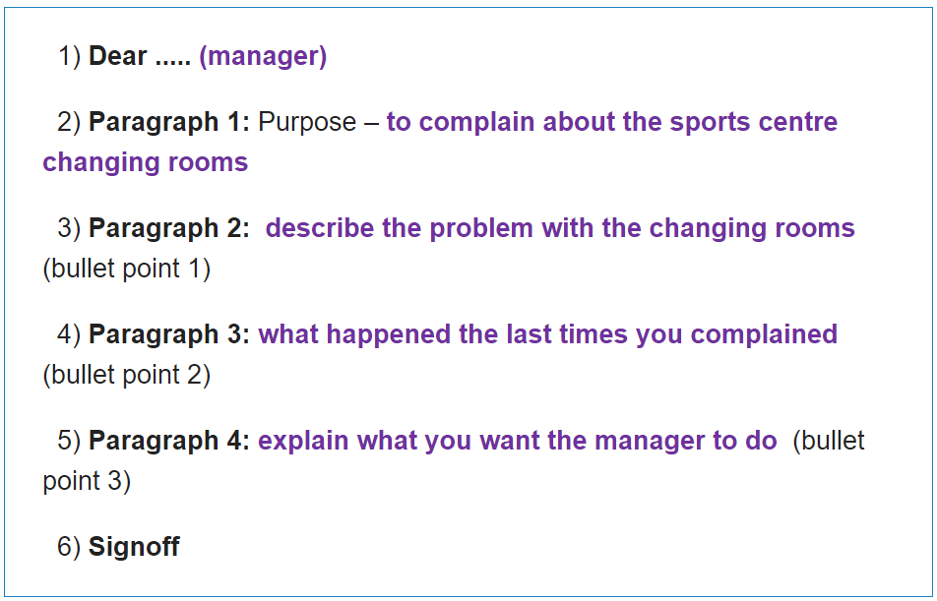

**The Greeting**

There are two ways you can begin your formal IELTS complaint letter.

* Use **Dear Sir or Madam** if you don’t know the name of the person you are writing to.
* Use **Dear + surname**if you do know their name, e.g. **Dear Mr Smith** or **Dear Mrs Jones**.

**The Signoff**

For a formal letter, there are two main options. The correct one will depend on who you are addressing:

* Dear Mrs Jones (name known) – **Yours sincerely,**
* Dear Sir/Madam (name unknown) – **Yours faithfully,**

**Paragraph 1**

* In the first paragraph, you must state the reason for writing the letter, that is, its purpose  
  **Paragraph 1:** Purpose – **to complain about the sports centre changing rooms**
* **I am very unhappy with / about + V-ing/ Noun phrase**
* **I am writing to complain about + V-ing/ Noun phrase**
* **I am extremely dissatisfied with / about + V-ing/ Noun phrase**
* **I am writing to express my dissatisfaction with + V-ing/ Noun phrase. Please let me elaborate on exactly my situation.**

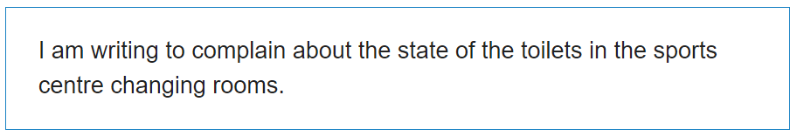

Please let me elaborate on exactly my situation.

**Paragraph 2**In the second paragraph, you write about bullet point 1.  
**Paragraph 2:**  describe the problem with the changing rooms (bullet point 1)

To explain in more detail,

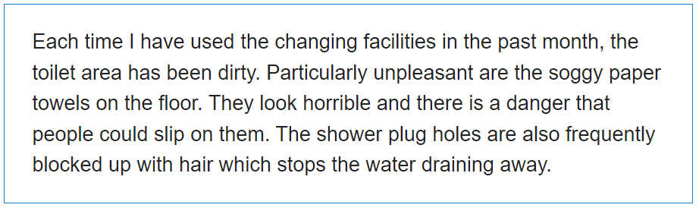

**3. what did you do to resolve the situation**

* + I contacted your store immediately in order to … ... but …..
  + When I tried to contact you by phone, no one could offer me any sensible answers.
  + I have told your staff about the problem but …
  + I have called your company by phone number and talked directly to …. However,
  + **how do you feel about the problem**
  + You cannot imagine how receiving this offer upset me.

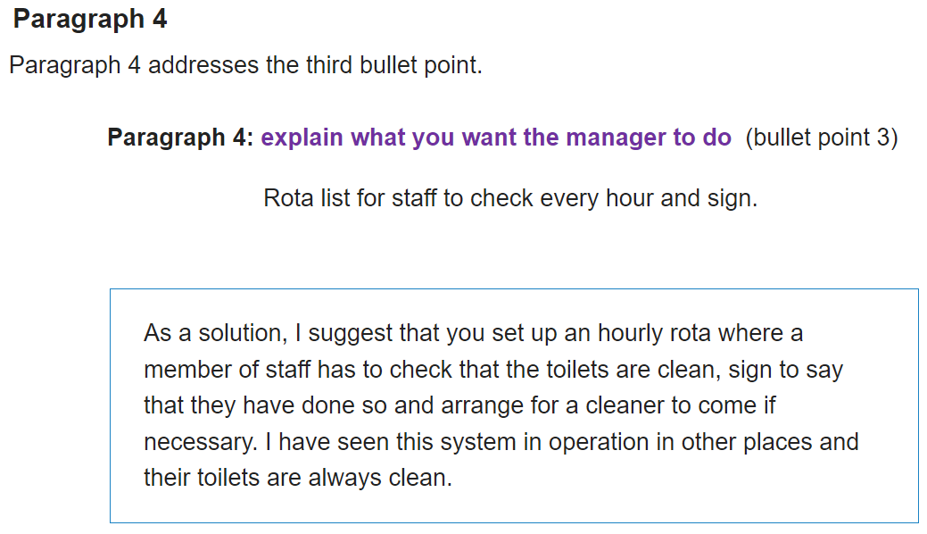

**4. What action you want the person or company to take / What would you like them to do, what will you do?**

* + The ideal solution would be ... / Nevertheless, I hope/assume you will replace ...
  + I hope you can settle this matter by ... (doing sth)
  + As a solution, I suggest that you should ….
  + In order to solve the problem, I suggest that …
  + I am very disappointed with the ... . Therefore, I expect a full refund of $100 as soon as possible.

🡪 I hope this matter will be resolved / I trust the situation will improve.

**5. Formal ending, name, signature**

* + I look forward to hearing from you!
  + I look forward to receiving a prompt reply!
  + **I await your response and hope this matter can be solved very soon.**
  + Yours sincerely, (you know the name of person you are writing to)
  + Yours faithfully, (you don't know the name!)

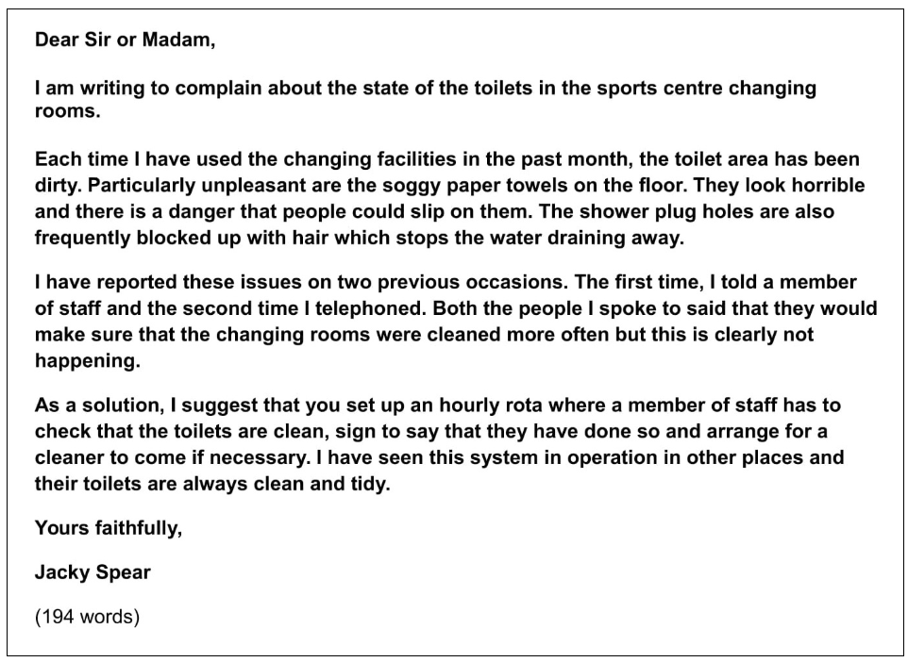

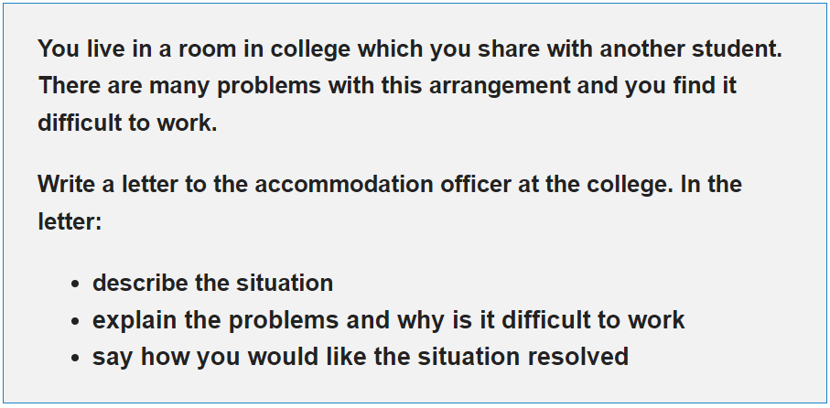

**Dear Sir/ Madam**

I am writing to express my dissatisfaction with … Please let me elaborate on exactly my situation.

…

…

In order to solve the problem, I suggest that ... … I trust the situation will improve.

I await your response and hope this matter can be solved very soon.

Your faithfully,

Ms Ha

